

CIS C290

M05 Assignment: Supervised Learning

Part 1. Using the shopping.csv file, run a logistic regression OR a classification tree to determine ‘purchase’ based on the seven other variables and write 3-4 sentences describing the data results. Include a screenshot of the Python output.

With the Classification Tree ran, the classification tree model is able to predict the purchasing pattern 53% of the time. One thing to note is that the ‘available_in_store’ parameter has no effect on the prediction. Overall, the model does not seem to fit the training data well enough to trust it, which could improve with some hyperparameter tuning.
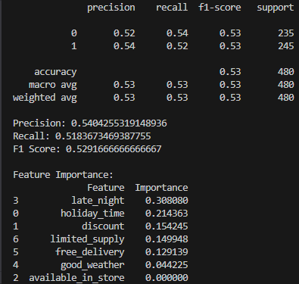
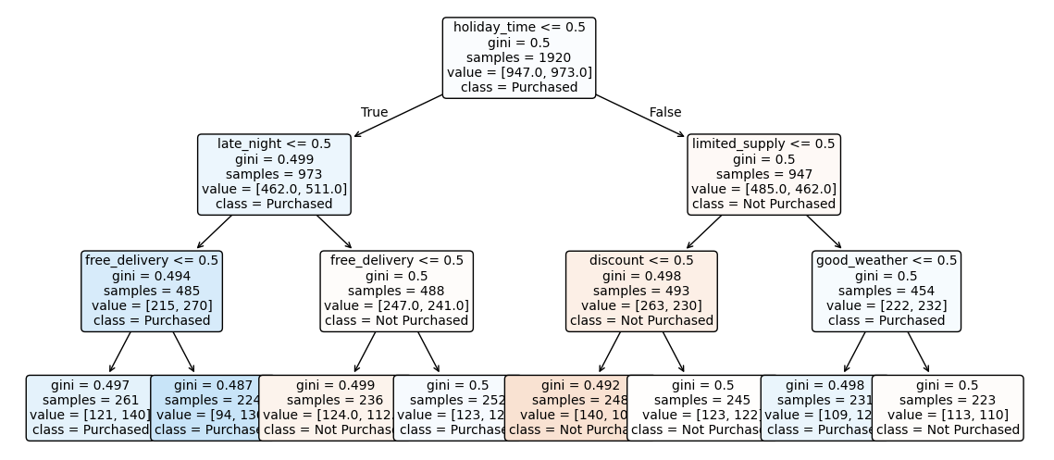

Part 2. Using the taco_sales.csv file, run a time series analysis to model the next 30 days of multiple linear regression on the student ‘marketing_dollars_spent’ based on all the variables in the dataset and write 3-4 sentences describing the data results. Include a screenshot of the Python output.

Based on the graph, the marketing dollars spent seems to rise and drop constantly between $50 to $1000. The forecasted marketing dollars spending in the near future should also fall within this range, which indeed it did. Overall, the time series analysis model fits the dataset well and predicted the behavior of the store’s spending behavior.
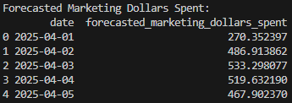
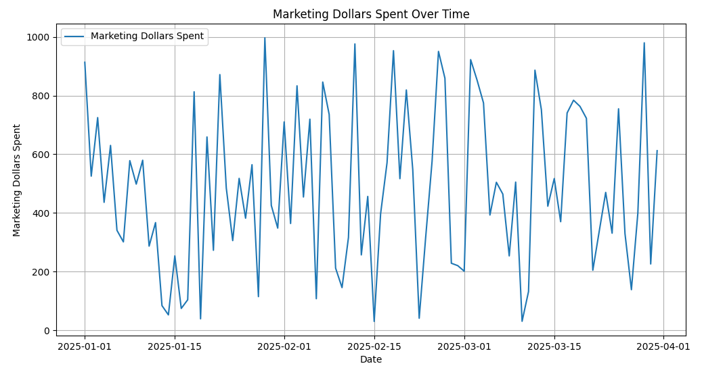

Part 3 FOR PRACTICE. Using the customer_loyalty.csv file, run a support vector machine to model if the customer ‘Has_Credit_Card’. Write 2-3 sentences describing the data results. Include a screenshot of the Python output.

Based on the 2 graphs the loyalty_status parameter seemed to skewed the dataset, causing the prediction precision to be about 50%. The other parameters such as annual income and spending score have only less than 5% importance. This is possible to be fixed through different kernel mode.
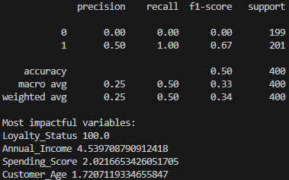
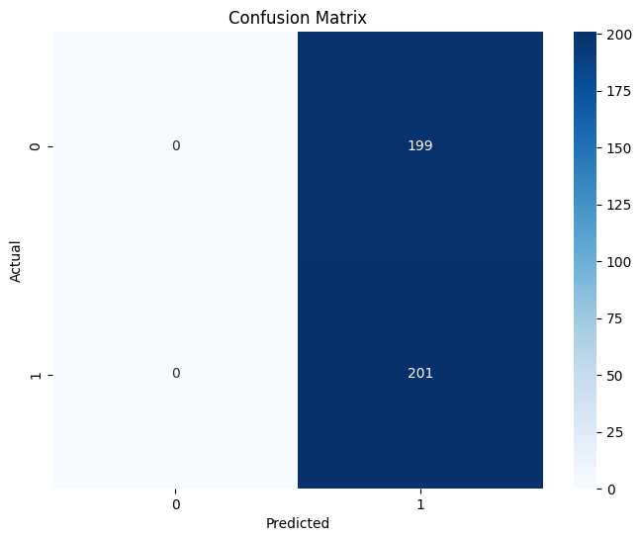
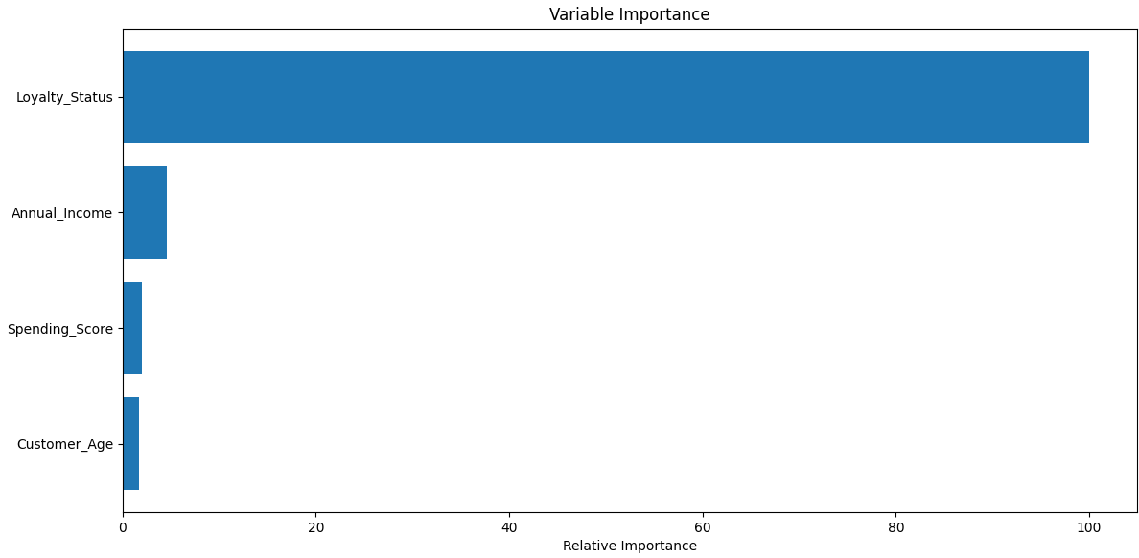

Part 4. In a minimum of 3 sentences, describe your experience with the assignment. Indicate which resources you used.

Throughout this assignment, two out of the three had bad predictive powers due to a dominant parameter within the dataset skewing the overall model. Despite tuning some of the parameters and model variations, the predictive power was unable to correctly predict the outcome. Overall, this assignment did not proceed successfully.

